Anti-fraud

Every time a financial transaction is created it must be validated by our anti-fraud microservice and then the same service sends a message back to update the transaction status. For now, we have only three transaction statuses:

1. pending
2. approved
3. rejected

The following are the rejection criteria:

* Every transaction with a value greater than 2000.
* Accumulated per day is greater than 20000.

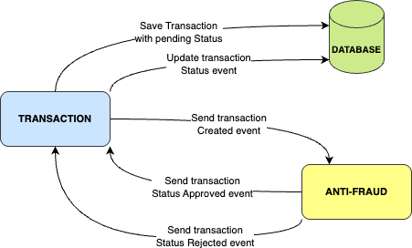

# Tech Stack

1. .Net 8
2. Any database
3. Kafka

We do provide a Dockerfile to help you get started with a dev environment.

You must have two resources:

1. Resource to create a transaction that must contain:

|  |
| --- |
| {  "sourceAccountId": "Guid",  "targetAccountId": "Guid",  "tranferTypeId": 1,  "value": 120  } |

1. Resource to retrieve a transaction

|  |
| --- |
| {  "transactionExternalId": "Guid",  "createdAt": "Date"  } |

# Send us your challenge

When you finish your challenge, reply to us with your solution. There are no limitations to the implementation, you can follow the programming paradigm, modularization, and style that you feel is the most appropriate solution.

If you have any questions, please let us know.